# Upload Tool Manual

## Introduction

Upload Tool is an application which is developed as part of TreeMapIndia project by GISE Advanced Research Lab, IIT Bombay. This application functionally divided into two parts one is on server side in the form of servlet another is on client side in the form of android app. At client this app is very useful in uploading survey data to specific server.

## Client Application

Client application is on android platform, in every android device there is a folder called treemapindia this contains survey sessions data. Client app list out all these sessions to user so that he is able to select which session to upload, following Figure explains how to use this app.

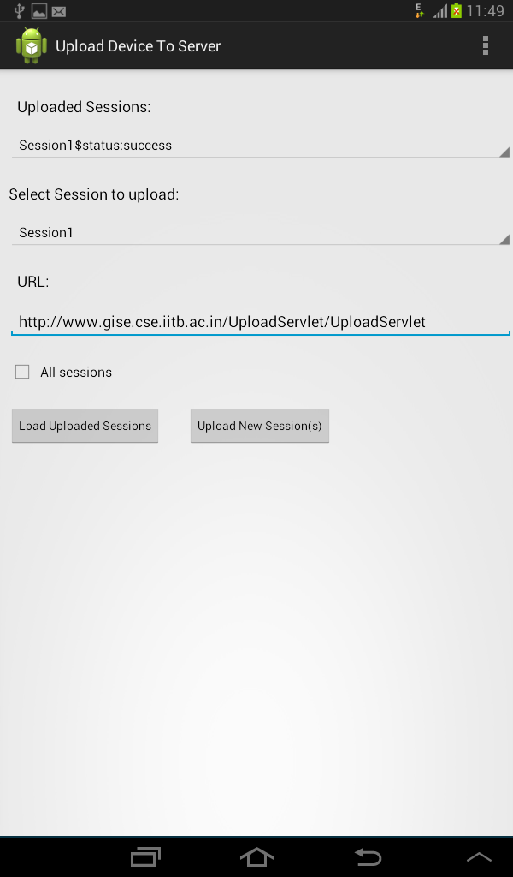

Uploaded Sessions: is a dropdown (spinner)list shows all uploaded sessions till now, to load this list click on “Load Uploaded Sessions” button. Each item in list is named as session name and upload status (success or error), in the case of error name is appended with http response code from server so that based on this we can identify problem.

Select Session to upload: is a dropdown (spinner) list shows all session present in your device where you can select a particular session to upload.

URL: is a textbox where you can specify url of server to which sessions to be uploaded.

All Sessions: is a checkbox if you check this all sessions in “Select Session to upload” list will upload to server irrespective your selected session at “Select Session to upload”.

Load Uploaded Sessions: is a button, as mentioned above this is used to load uploaded sessions to list “Uploaded Sessions”.

Upload New Session(s): is a button, click on this to upload session(s).

## Server Application

A servlet must be deployed at server side to handle upload request from client. This servlet will attach a **time stamp** to every incoming session i.e each session folder is named with session name and time stamp.

### Assumptions

* **Each android device contains a folder named “treemapindia” in its external SD card and all sessions stored in that folder only.**
* **Each session is a folder which contains all images, csv files and kml files related to that particular session.**
* **Each session folder named as session name.**
* **Inside “treemapindia” folder a file named sessions.txt must be created, content of this file is all session (session folder) names separated with new line. Upload application uses this file to know what sessions present.**
* **Inside “treemapindia” upload app creates a file called “sent.txt”, content of this file is all uploaded session names with status of upload (success and error). In the case of error each session name appended with http response code.**

### Architecture

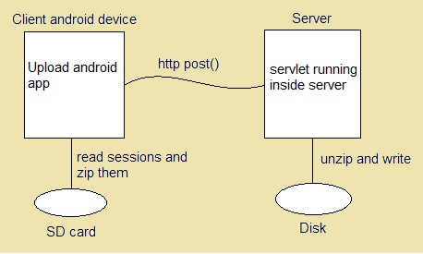

Fig: Upload Tool Architecture

### References

<http://stackoverflow.com/questions/14417849/android-file-upload-using-a-post-method>

<http://stackoverflow.com/questions/2017414/post-multipart-request-with-android-sdk>

<http://stackoverflow.com/questions/11646025/data-compression-on-android-other-than-java-util-zip>

<http://stackoverflow.com/questions/13395218/android-compressing-folder>